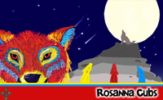

Rosanna Cubs
THIRD Pack Holiday
Gilwell Park, Gembrook

Fri 12th -Sun 14th Nov, 2010
Cowboys & Indians!


Hi. After the fantastic fun we had last year, it’s time for Rosanna Cub Scouts THIRD Pack Holiday. With a theme of Cowboys and Indians, we’re travelling to Gilwell Park Scout Camp, near Gembrook. We need some Cowboys and Indians to go back to the Wild West – and you’re invited! Come along as we go to the hills around Gembrook – to have the best fun ever!

Location: Gilwell Park Scout Camp, Launching Place – Gembrook Rd, Gembrook
About it: We will be staying in the E.M. Derrick Pack Holiday Centre, comprising Bunk rooms, which will easily accommodate our Cubs in boys only/girls only rooms, plus separate male and female accommodation for Leaders and helpers. Also, Kitchen, dining room, toilet and shower facilities. The Scout Camp is in a bush setting with plenty of onsite activities for our Cowboys and Indians.
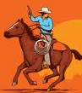
Transport: We will most be travelling by bus
– approx 2 cars will also be going.
Cost: $80 – includes transport, accommodation, food and activity equipment
Leaders: Our Leaders will be attending, plus we’re looking for volunteer parents for
Cooking (please respond ASAP).
Depart: Meet at the Scout Hall at 6pm, Fri 12th Nov. - Ready for a 6:30pm departure.
Return: 1:45 pm Sunday, 14th Nov – depart from Gilwell
3:15-3:30 pm arrive back at Scout Hall.
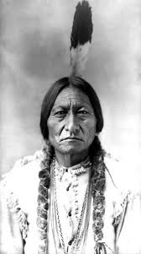
Take: Kit list is available on the paperwork/downloads page of our website. Printed copies will be given to those without net access. NOTE: All our Cowboys and Indians can bring along an appropriate costume if they like. ALSO, very old clothes for the Battle of the Little Big Horn (flour fight) and, depending on weather, we may get to do the Gauntlet – clothes will get lovely and dirty AND large plastic bags for safe return of the clothes home!
NO: Phones, MP3 players, electronic games, radios or similar may not be taken.

To allow planning, Please return the form below and minimum $20 deposit by Tuesday week – 26th Oct. The balance ($80 all up) will be required at the latest by 9th Nov.
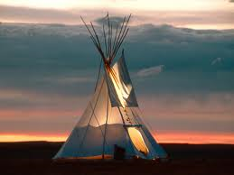
Regards

The Leaders
Rosanna Cub Scouts See us at http://www.rosannacubs.org

Permission Form - Rosanna Cub Scouts

I, ______________________________________ give my permission and attach $20 deposit (or full $80)

for ___________________________________ to attend the 2010 Pack Holiday at Gilwell Park, 12-14 Nov

Special Dietary Requirements (for catering purposes) _____________________________________

I understand that transport to and from the camp will be by bus or provided car
Signature of parent or guardian ______________________________

